Title: | Door Control Module  SW Component SafetyManager

History
Issue status  (Index) | Maturity/Date  (draft/invalid/valid)  (dd-mmm-yyyy) | Author  Department | Check/Release  Department | Description
1.0 | Draft  02-feb-21 | Marco Antonio Romo Ramírez | - | Creation of the document

Table of Contents
1 Purpose 3
2 Definitions and abbreviations 3
3 Realization constraints and targets 3
4 SW Conceptual design 3
5 SW Component internal breakdown 4
5.1 Functional Decomposition 4
5.2 Function Void activity_SafetyDecisions(void) 4
5.3 Function Void WriteActuationState(WindowActuationState* WindowAtuationState) 5

Purpose
This document shows the corresponding interfaces of the SafetyManager software component. This component will handle all the logic necessary to handle AntiPinch events.

Definitions and abbreviations
Definitions
NA

Abbreviations
SWC Software Component
References
N° | Document name | Reference
1 | SW Architecture | Commit:
 |  | ddc45822a03f9f1781eaa4fc5b6d5874311f8e1b [ddc4582]

Realization constraints and targets
The objective of the SafetyManager component is to execute window action cancellations, in order to prevent a person from getting hurt.

SW Conceptual design
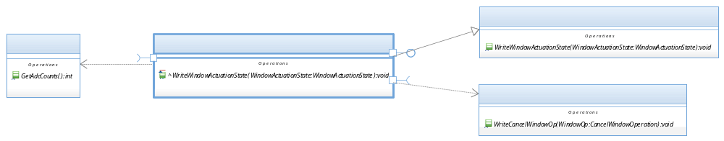

SW Component internal breakdown

Functional Decomposition

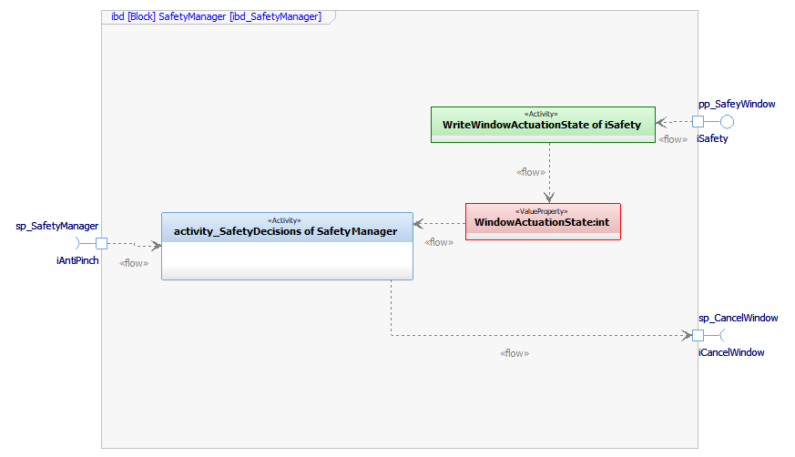

Function Void activity_SafetyDecisions(void)

Description | The function is used to execute a CANCEL_WINDOW_ACTUATION if it detects that the security threshold passed the reference value.
Parameter 1  <input| output| inout> | NA – Does not use parameters.
Parameter 2..n | NA – Does not use parameters.
Return Value | void
Precondition | The function depends on "SensorManager" to be able to make a decision and perform an action
Post condition | When the function makes a decision, it must be sent to WindowControlApp
Error Conditions | NA – Any error condition identified yet.
Requirements | NA – Review traceability matrix

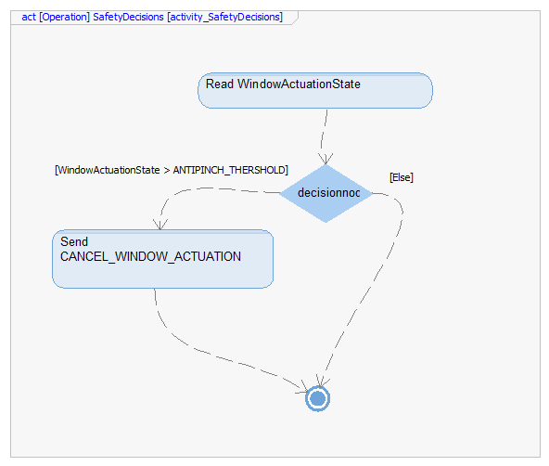

Function Void WriteActuationState(WindowActuationState* WindowAtuationState)
Description | This function is called by iSafety to update the WindowActuationState variable.
Parameter 1  <input| output| inout> | WindowActuationState* WindowAtuationState <output>
Parameter 2..n | NA – Does not use more parameters.
Return Value | NA – Does not return a value.
Precondition | SWC shall be initialized first
Post condition | The “activity_SafetyDecisions(void)” functio uses the interface information
Error Conditions | NA – Any error condition identified yet.
Requirements | NA – Review traceability matrix

